***Applied Data Science Capstone Project***

***IBM Data Science Professional Certificate***

*Mel Fuechec*

*December 2020*

1. Introduction

This analysis aims to identify similar neighborhoods in major cities across the United States for the purpose of expanding business franchises. The target audience and stakeholders here are franchise owners, real estate investment firms, and/or banks.

For example, if a pet grooming boutique, vegan bakery, vintage comic-book store, fast food, etc. franchise is successful in one neighborhood in NYC and would like to expand to another city, it may be more likely to be successful in a neighborhood with similar characteristics as the original NYC neighborhood.

The franchise is interested in finding the most successful location for their expanding business. The real estate investment firm is interested in buying up lucrative real estate. The bank is interested in understanding the risk/reward of making loan agreements.

2. Data

This analysis will rely heavily on the Foursquare location data as well as the neighborhood HTML table data from Wikipedia. Data will be scraped and parsed from Wikipedia using the Python package Beautifulsoup and converted into a pandas dataframe. K-means clustering analysis will be applied to the data. The neighborhoods in cities across the United States will be segmented and clustered into similar neighborhoods.

3.Methodology

Exploratory data analysis was performed using the count, groupby, and unique methods to find the number of neighborhoods and number of venue categories. Then one hot encoding was used to convert the categorical venue data to numeric data. The neighborhoods were grouped together. A function to aggregate the ten most common venue types for each neighborhood and sort in descending order is applied to the neighborhood-grouped venue data.

K-means data analysis was chosen to cluster the neighborhoods by their likeness based on most common venue types. 6 clusters were chosen as they showed to give the most balanced clusters.

Maps were created using the folium library for each city to visualize the results.

4. Results

The analysis shows us that of the 294 neighborhoods included in the analysis, the vast majority, 233, were grouped into cluster 4 which we have deemed to be "Varied Neighborhoods" spans all cities in the analysis.

33 neighborhoods are in Cluster 3 - Restaurants & Shopping Neighborhoods, mostly in Toronto and LA.

21 neighborhoods are in Cluster 2 - Parks & Outdoors Neighborhoods, mostly in Toronto and LA.

Three neighborhoods were grouped into cluster 0 which we have characterized as "Construction & Landscaping, Yoga, & Farmers Market Neighborhoods, one in LA and 2 in Toronto.

Three neighborhoods belong to Cluster 1 - Business Services, Electronics, & Empanadas Neighborhoods and they are all in the North of LA.

Cluster 5 - Sporting Goods and Yoga Neighborhood consists of a single neighborhood in central LA.

Los Angeles

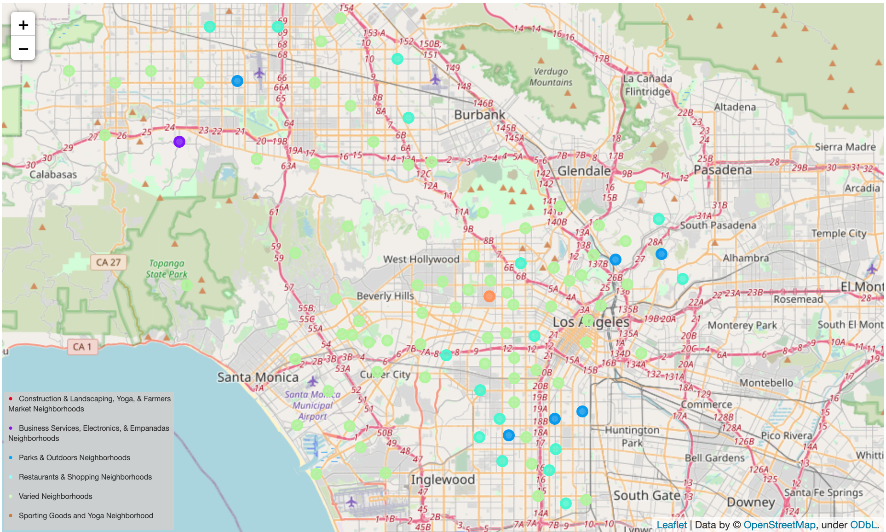

Toronto

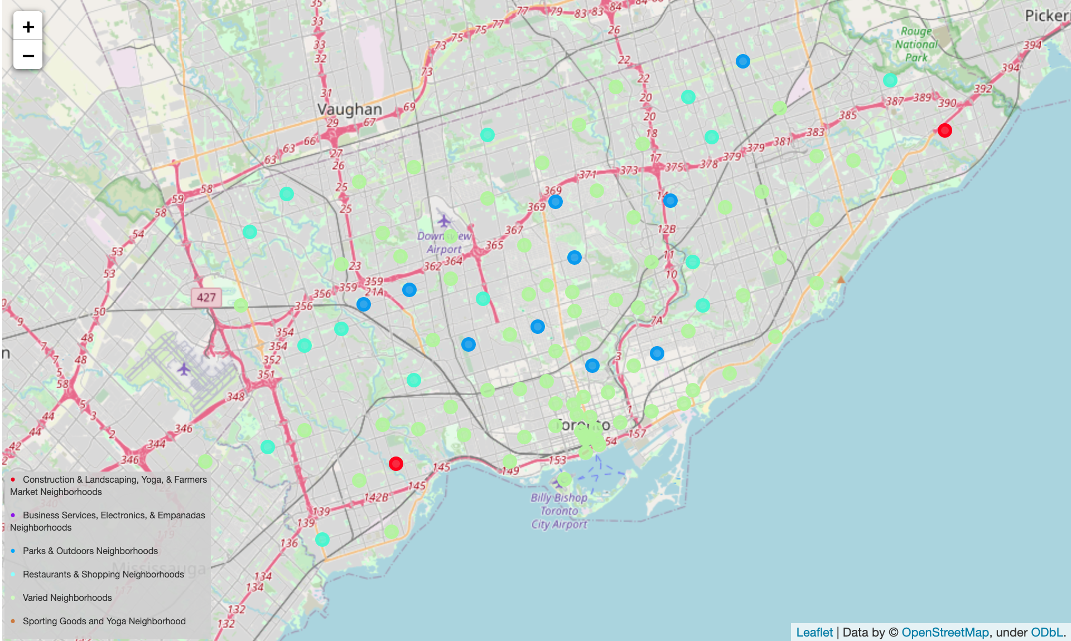

Miami

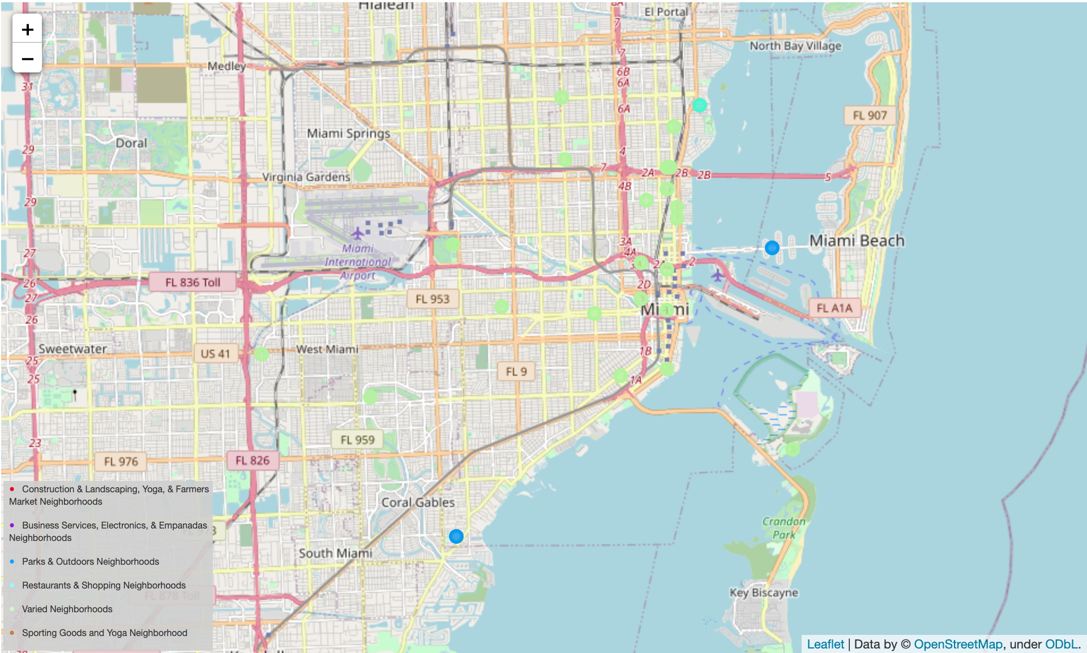

San Francisco

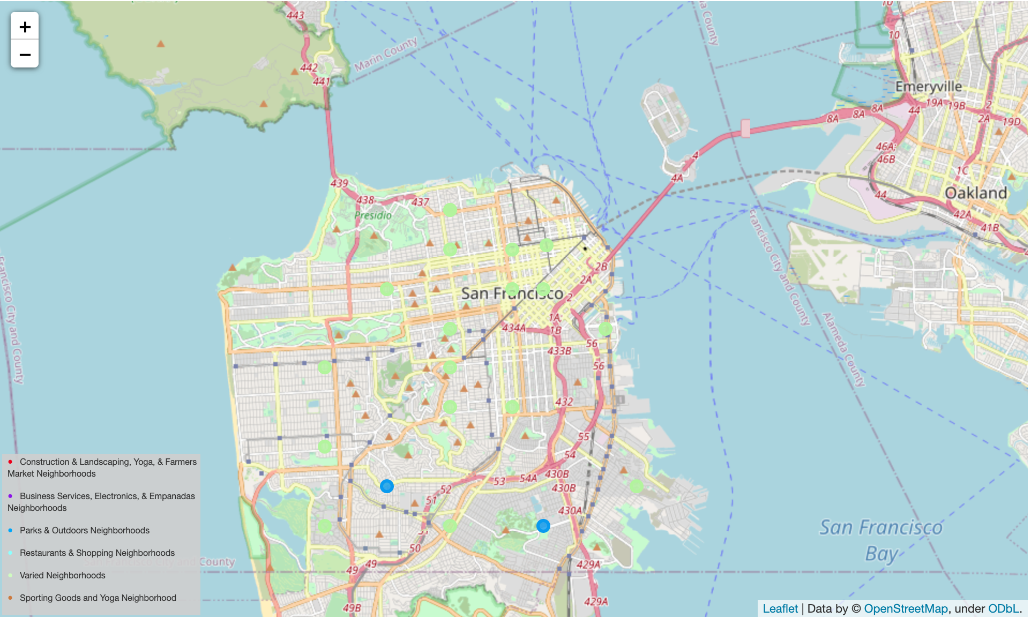

Manhattan

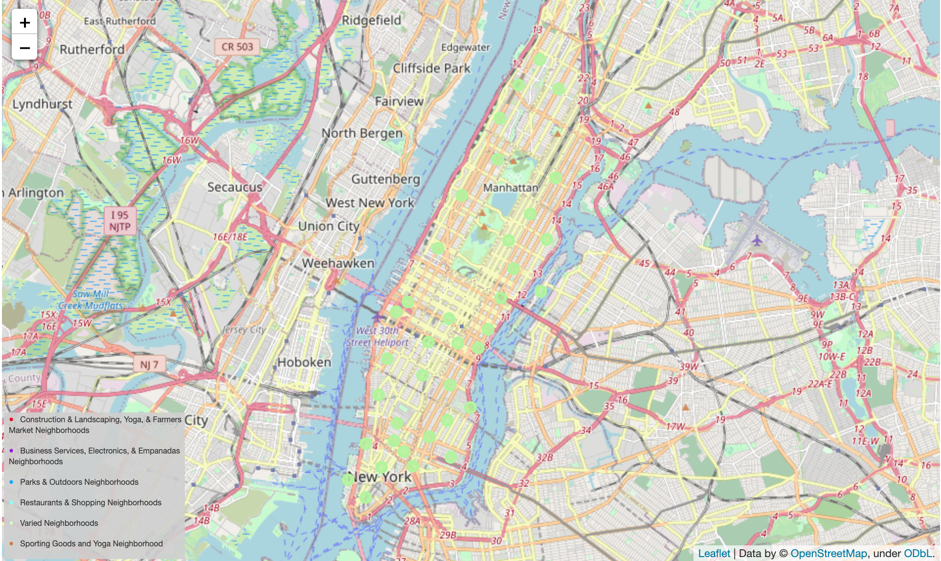

5. Discussion

I believe the analysis was skewed by uneven cluster size and possible outliers. However, some distinctions to be made are that Cluster 4 is the cluster of diverse neighborhoods with a variety of venues, and so it may make sense that Manhattan is made up of entirely this cluster. The central city of the cities analyzed is also primarily cluster 4.

Toronto and LA are the cities with the most Restaurants and Shopping and Parks and Outdoors. Let's go!

Moving forward, I would try this analysis again using the DBSCAN method which has advantages over k-means such as the clusters formed are arbitrary in shape and may not have same feature size.

I would also style the maps so that the cluster markers stand out more.

6. Conclusion

In conclusion, while this may not be the most solid data analysis out there, I certainly learned a lot about the different Python libraries used in data science and about some of the statistics behind the code.